**EXPERIMENT – 5**

**AIM :**

Write queries to implement Built-in functions – GROUP BY, HAVING AND ORDER BY

**THEORY :**

In this experiment we will see the implementation of built-in functions – GROUP BY, HAVING AND ORDER BY. They are used to manipulate the representation of the table. They are always used with SELECT command.

* GROUP BY: used to arrange identical data into groups with the help of some functions.
* HAVING: used to apply a filter on the result of GROUP BY based on the specified condition.
* ORDER BY: used to sort the fetched data in either ascending or descending according to one or more columns.

**PROCEDURE :**

**GIVEN TABLES:**

**1. BORROW:**

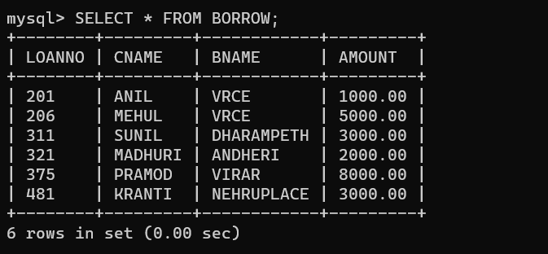

**2. CUSTOMERS:**

**3. BRANCH:**

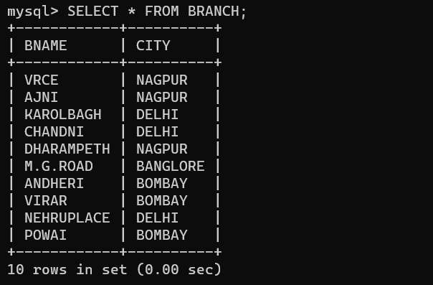

**4.DEPOSIT:**

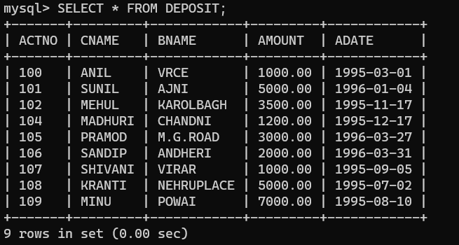

**QUERIES BASED ON GROUP BY, HAVING AND ORDER BY CLAUSE:**

**QUERY(i) :** List the branches having sum of deposit more than 5000.

**OUTPUT:**

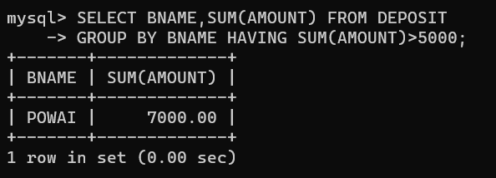

**QUERY (ii):** List the names of customers having deposit in branches where average deposit is more than 5000.

**OUTPUT:**

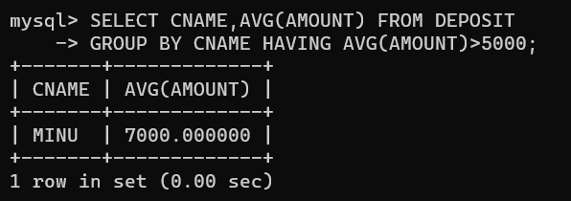

**QUERY (iii):** Give details of depositors in ascending order of their deposit amount.

**OUTPUT:**

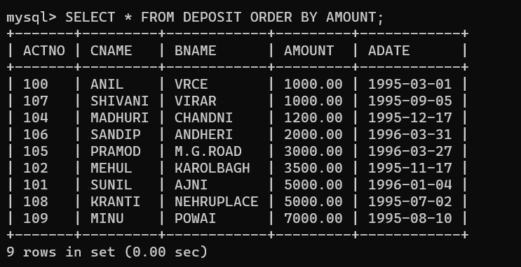

**QUERY (iv):** Give details of borrowers in descending order of their loan amount.

**OUTPUT:**

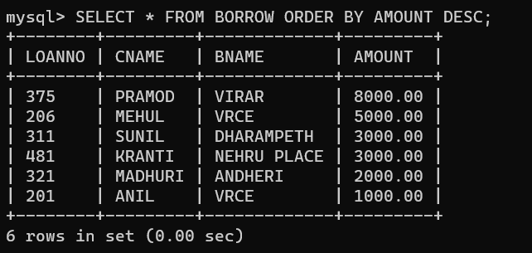

**QUERY (v):** Give number of branches located in the cities in ascending order

**OUTPUT:**

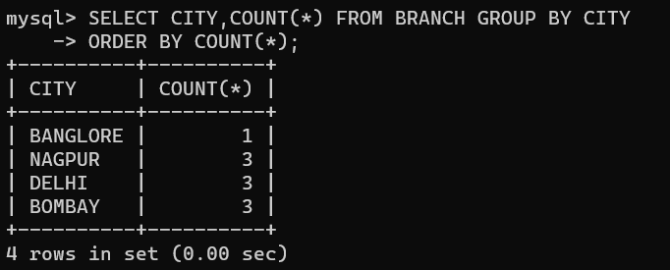

**QUERY (vi):** Give name of city having more customers living in than NAGPUR.

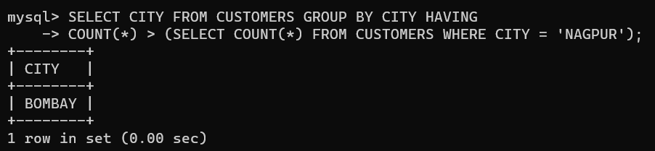**OUTPUT:**

**QUERY (vii):** Give amount of loan taken from different branches.

**OUTPUT:**

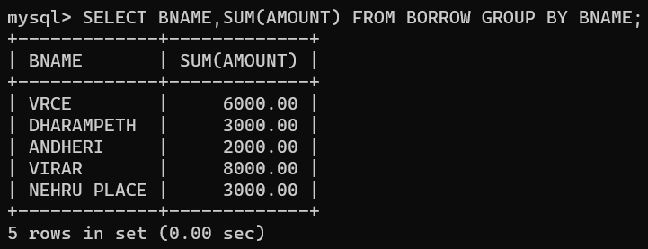

**QUERY (viii):** Give name of customer having maximum deposit among customers living in BOMBAY.

**OUTPUT:**

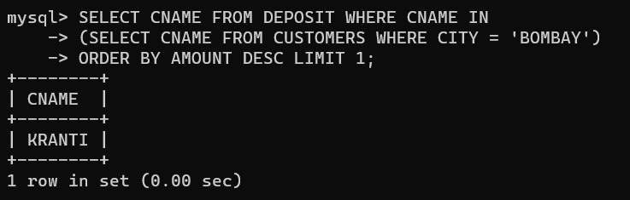

**QUERY (ix):** Give name of CITY in which maximum number of branches are located.

**OUTPUT:**

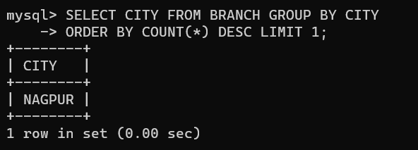

**QUERY (x):** Give name of branches located in the city which has maximum number of customers.

**OUTPUT:**

